Pass for level 20:

Step 1: Login to natas 19

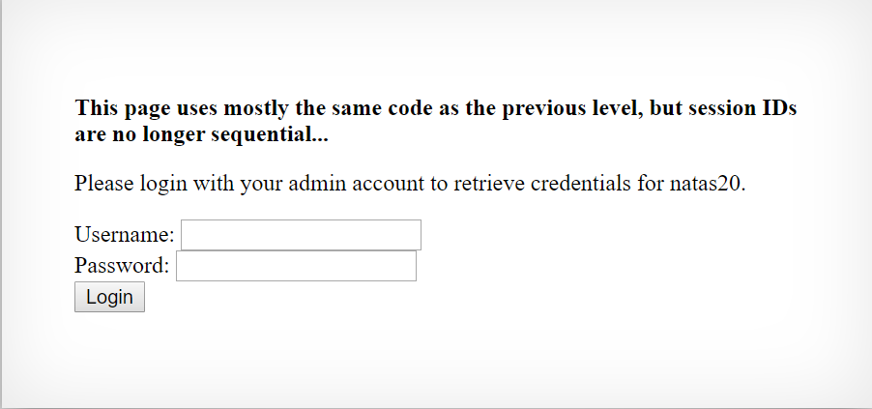

There isn’t any source code to view but they telling us that is the same code with a bit changes.

While in the last level the PHPSSID cookie value was sequential (1,640]

Now for username: Michael and Password: Perry 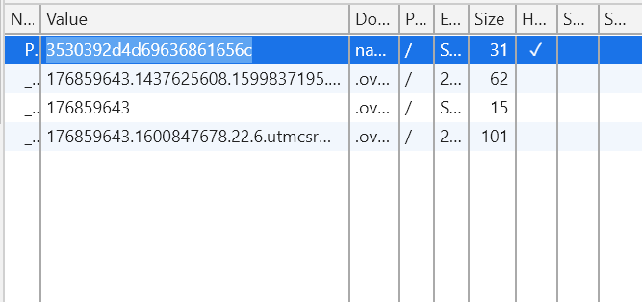

We got some string that look like as HEX code.

After some playing with the values we post to the server with Username and Password we see that the last string stick the same.

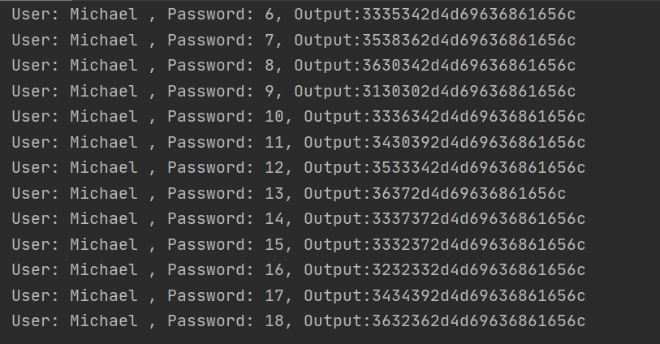

Step 2:Decode the output from hex to string

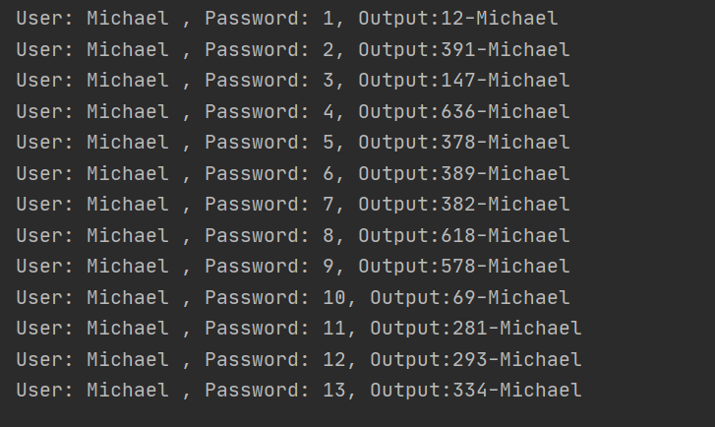

Step 3: Post brute force cookies with password convert from hex to ascii in range of [1,640]

And find the credential.

